Sam Hapke
CIS 171
Midterm Project Reflection
9/28/2025

You will be asked to complete these reflection questions for your midterm project. Keep the
original questions and answer below them
1. Briefly explain the IPO features of your program (Input, Processing, and Output)
o What is your input (include data types)
o What do you do for processing?
o What is your output (include special formatting)
My program takes in only Strings, and depending on the exact string, it will carry the user through many different options some of them requiring more String inputs, and eventually coming back to the original loop. The outputs are Strings, Ints, Doubles, ArrayLists, and lots of white space so that hopefully it feels readable, and engaging.
2. What is/are the name(s) of the classes you imported
I am using the larger Adventurer class, as well as a much smaller Item class.
3. What is/are the name of the java class(es) that contains your source code?
GoingOnAnAdventure.java, runAdventure.java, Advenrurer.java, Item.java
I am second guessing my decision to pull as much as I did from Going… into run… but I wanted to keep Main nice and simple. Now I’m feeling like run… is getting bogged down too. I could split it again leaving runAdventure.run as its own class, and have several classes for the different switch branches. Or I could just slap it all back into main. I’m leaning more to the additional classes per switch case.
4. Where in your code is your user input? (provide line number and screen shot of the code)
Several places. The first and second are in Main, in Going… at lines 17, and 25.
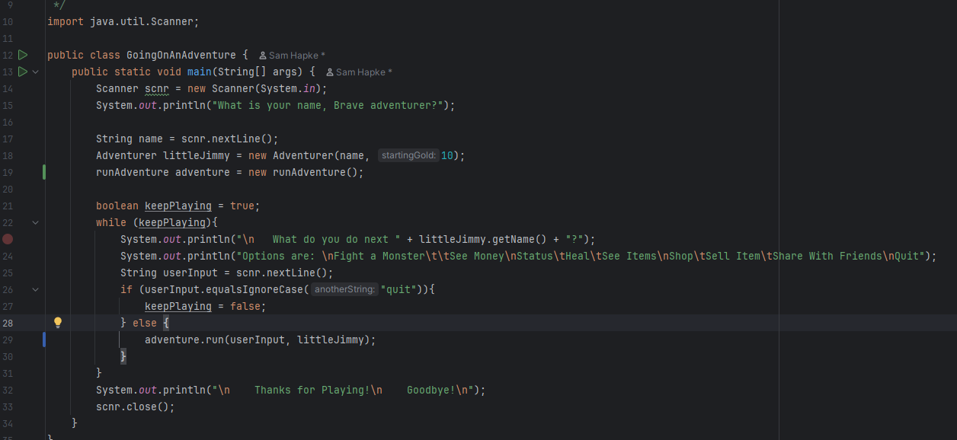
5. Which String method does the program utilize? (provide line number and screenshot of
the method being used – provide a few lines of code for context)
I don’t alter Strings much, though I craft a fair few. The most important String method I use is .toLowerCase(), at my switch statement to avoid dealing with capitalization in user inputs: run… line 6.
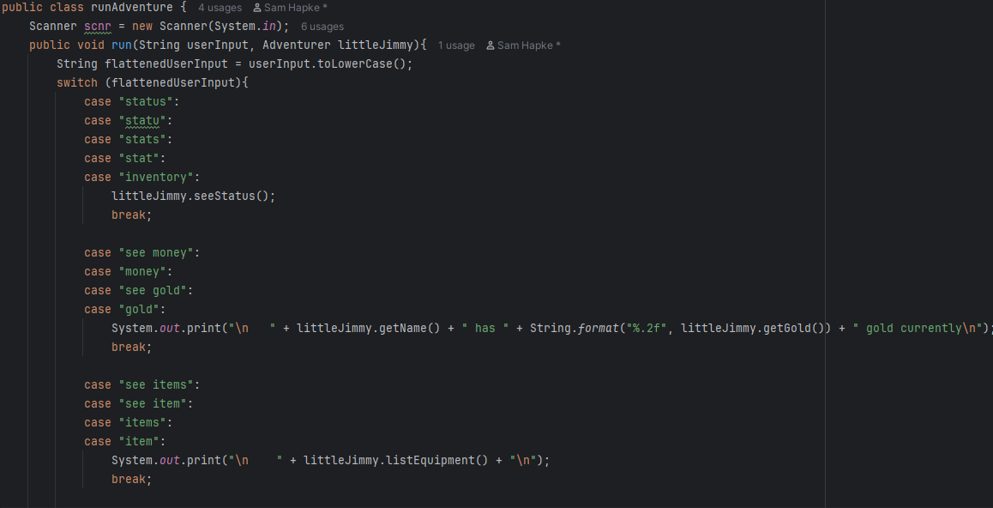
6. Choose one decision structure in your code and explain its purpose and why you
designed it the way you did. (provide starting line number)
I used an if else if structure in my runCombat() method, that split combat success into 5 tiers, GreatSuccess, Success, Fail, MajorFail, and fatal failure. fightResult is a random number between 0 and 100, and it determines the success level. I wanted success to have a lot of options, so descending from best to worst outcome, there is success, without consequences, success, but taking damage, fail and taking damage, fail and taking extra damage, and outright death for the character. run… line 123 to line143
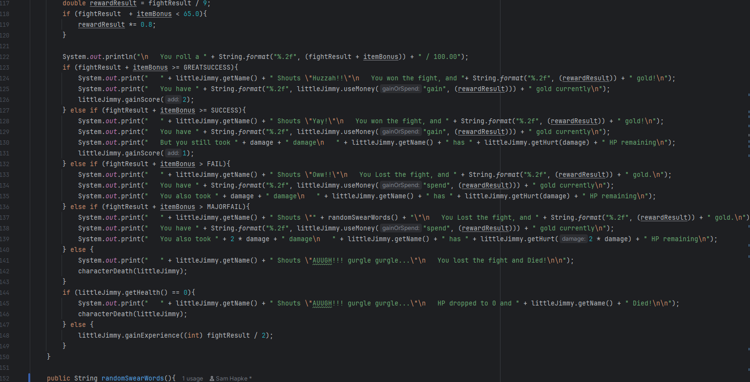
7. What mathematical operations did you perform (other than simple increment/decrement s
++, --). (provide starting line number)
I use many Math.random()s, as well as Math.ceil(), and a Math.abs(). Math.random in run… lines 71, 94, 96, 153. Math.ceil in run… line 96. Math.abs in run… line 245
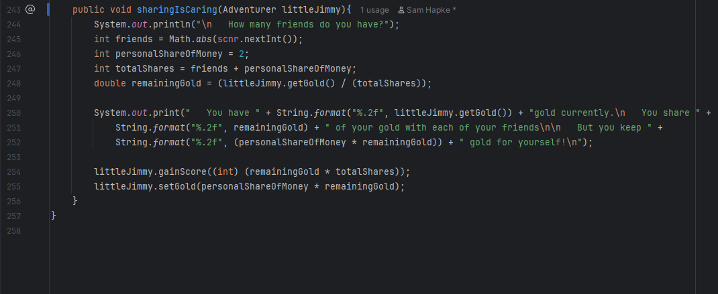
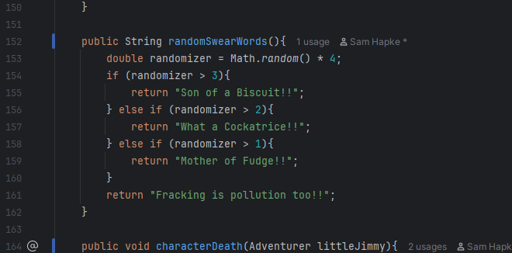
8. Describe one looping structure you used and why you implemented it the way you did?
(provide starting line number)
My primary loop is in Going… line 22. It prompts the user to take the next action, until they are ready to quit.
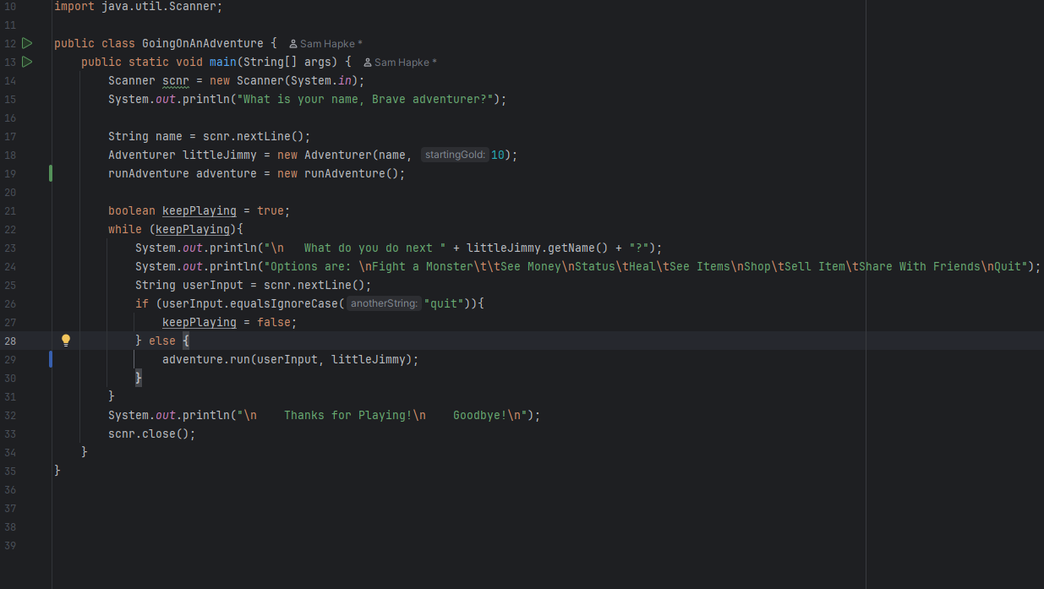
9. Describe one method you used. Explain why you designed your method the way you did?
Why the parameters you chose (including why you chose the data types used) and why
the return value/type you used. (provide starting line number)
Well, Most of my methods don’t have return types (or is void if you want to say it that way) so I’ll talk about public String randomSwearWords() run… line 152. I wanted to give a little variety to failure, so that it was less annoying, so I made a simple 4 choice randomizer to return a not-quite-swear-word to input into MajorFail text. Now I also realize that that is one of my few methods that doesn’t take a parameter. So, let’s talk about basically any other method, that takes in class Adventurer, typically alone. The class stores all the data I will need, that isn’t a randomly generated number, and gives me access within the methods, most methods either read from the Adventurer, or modify it.
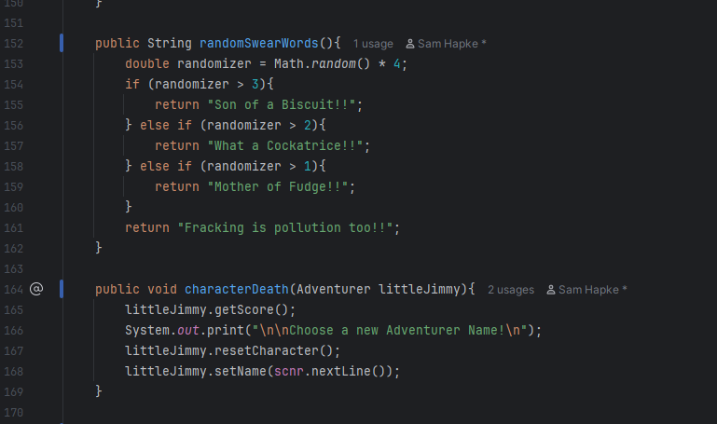
10. Which assert method(s) does your JUnit utilize?
I am currently using assertTrue, and assertEquals.
11. Do you feel you have enough Junit tests to cover all coding pathways? (100% code
coverage)
No. Frankly, by a lot. Many of my methods take in user input, and I have not dealt with how to enter predetermined input into the Scanner. I think we glossed over it in this weeks reading, but I will need time to play with it before feeling comfortable. Most of my methods also have output. So I also have to figure out how to match up output from System.out, with an expected output. I’ll have to find a way to watch and record what the console is displaying.
12. How did you make your program user friendly?
With lots of directions, and clear choices. I also set up my switch statement to use .toLowerCase() so that input can be understood regardless of case, and to include of couple abbreviations for things I believe might be shortened or guessed.
13. What did you like about the project?
I am enjoying watching it grow and improve. I like how I can go through, and decide I don’t like x or y, and adjust it so it looks, and feels and acts more like I want it to. I also enjoyed playing with the percentages, and trying to adjust, Balance, score, and fight probability and rewards healing cost, and result.
14. What were your stumbling blocks or things you wished you could have been able to do.
I have avoided the Jframes, for now. I wanted to function first, and I will make it look pretty later. I commented earlier about how most of my methods output, and return void. I will be able to leverage that later (I believe) to return a string; so that I can put that string into a nice frame.

